Random forest:

Best Roc AUC:

0.809

Roc curve graph –

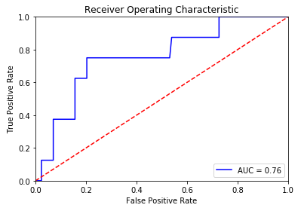

Prediction Distribution graph -

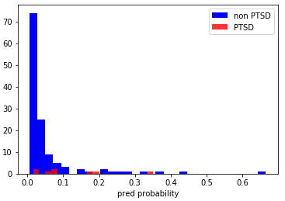

Precision score cv with best auc- 0.25

Best F1 score – 0.15

Precision score cv with best f1 - 0.25

XGBoost:

Best Roc AUC: 0.82

Roc curve graph –

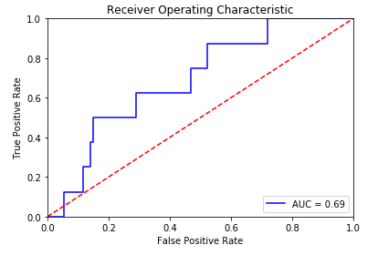

Prediction Distribution graph -

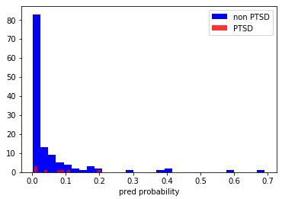

Precision score cv – 0.25

Best F1 score – 0.19

Precision score cv with best f1 - 0.225

SVC:

Best Roc AUC: 0.78

Roc curve graph –

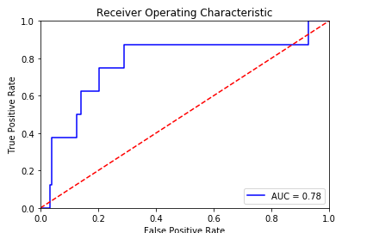

Prediction Distribution graph -

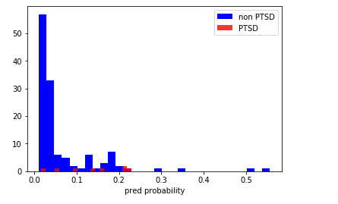

Precision score cv - 0

Best F1 score – 0.23

Precision score cv with best f1 - 0.28

MLP:

Best Roc AUC: 0.788

Roc curve graph –

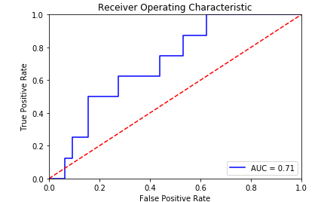

Prediction Distribution graph -

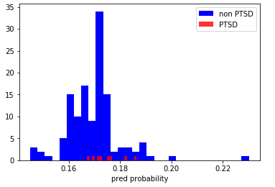

Precision score cv - 0

Best F1 score – 0.115

Precision score cv with best f1 - 0.06

And function xgb:

Best Roc AUC: no sure

Roc curve graph –

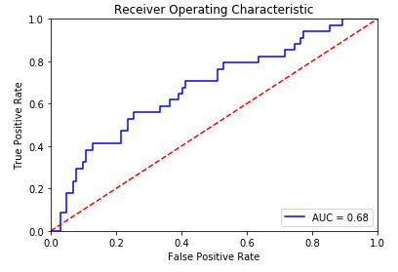

Prediction Distribution graph -

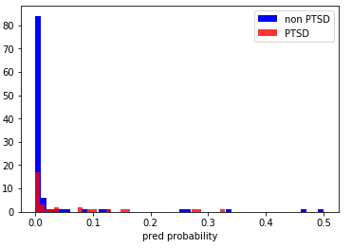

Precision score cv – not sure

Best F1 score –

Precision score cv with best f1 - 0.25

And function rbf:

Best Roc AUC: no sure

Roc curve graph –

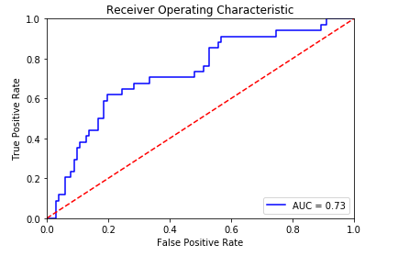

Prediction Distribution graph -

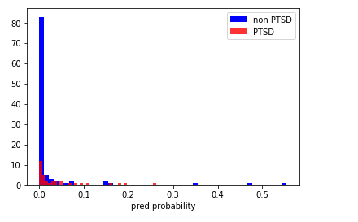

Precision score cv – not sure

Best F1 score –

Precision score cv with best f1 - 0.25